RESEARCH SYMPOSIUM PRESENTER
PRESENTATION TIME: 3:45 PM – 3:55 PM
PRESENTER: Jennifer Huang (MS2)

BUTYRATE-PRODUCING GUT BACTERIA AND VIRAL INFECTIONS IN KIDNEY TRANSPLANT RECIPIENTS

Jennifer Huang¹, Matthew Magruder¹, Lisa Zhang¹, Shady Albakry¹, Emmanuel Edusei¹, Eric Pamer², Manikkam Suthanthiran¹, John Richard Lee¹
¹Weill Cornell Medicine, New York, NY 10021; ²Memorial Sloan Kettering Cancer Center, New York, NY 10065

BACKGROUND. Recent studies suggest that the gut microbiome plays a critical role in protecting its host from infections beyond Clostridium difficile. Notably, butyrate-producing bacteria may be beneficial to gut health and have recently have been associated with lower rates of respiratory tract infections in bone marrow transplant recipients (Haak et al., Blood 131(26): 2978, 2018). In this study, we evaluated the relationship between butyrate-producing gut bacteria and future development of viral infections in kidney transplant recipients.

METHODS. We evaluated stool samples collected two weeks after transplantation from 115 kidney transplant recipients and profiled the microbiome using 16S rRNA gene deep sequencing of the V4-V5 hypervariable region. Based on a 1% relative abundance cutoff previously reported in Haak et al. 2018, we evaluated whether having a low abundance of butyrate-producers (<1% relative abundance) was a risk factor for development of three common viral infections within the first two years after kidney transplantation: BK viremia, cytomegalovirus (CMV) viremia, and respiratory tract (RV) infections.

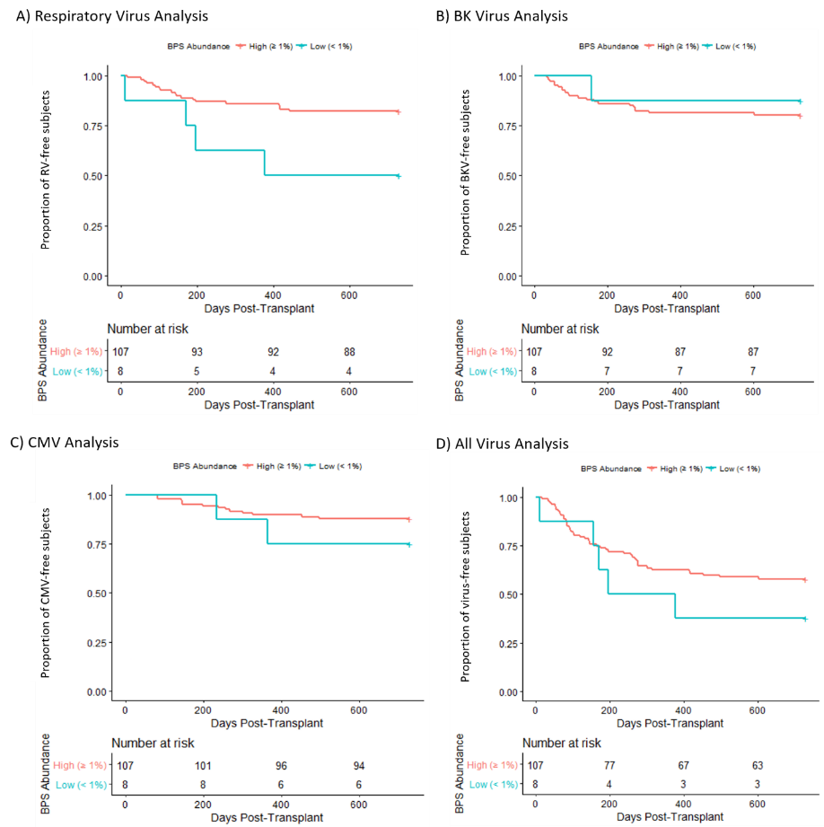
RESULTS. In the study cohort, 22 developed BK viremia, 15 developed CMV viremia, 23 developed RV infections, and 50 developed at least one of the three viral infections. Univariate Cox regression analysis showed that subjects with low abundance butyrate-producers had a significantly increased risk for developing RV infections than those with high abundance butyrate-producers (Hazard Ratio: 3.1, P=0.03) (Fig. A). There was no significant difference in the development of BK viremia (P= 0.62), CMV viremia (P=0.32), or a combination of the three viral infections (P=0.28) between subjects who had high vs. low abundance butyrate-producers (Fig. B-D).

CONCLUSIONS: Our results extend the novel association between the gut microbiome and development of viral infections from cell transplant recipients to solid organ graft recipients. Altogether, these findings support targeting the gut microbiota as a strategy to prevent and/or treat viral infections.

CONTENT CATEGORY: Clinical science, translational science

KEYWORDS: microbiome, kidney, transplant, virus

