IDENTIFYING MYOSITIS SPECIFIC T-CELL RECEPTOR

Xuwen Alice Zheng, Janelle Montagne Iago P. Fernandez, Lisa Christopher-Stine, Thomas E. Lloyd, Andrew L. Mammen, & H. Benjamin Larman
Larman Lab, Pathology Department, Johns Hopkins School of Medicine
2 W University Pkwy, # 405, Baltimore MD, 21218

BACKGROUND: Every T cell responding to a different antigen has a distinct T cell Receptor (TCR) that recognizes antigen. Since autoimmune diseases arise when T cell recognize “self” proteins as foreign, screening their T cell specificity can reveal how their immune responses differ from healthy individuals. However, accurately determining a T cell’s antigen specificity is a methodologic challenge. We hypothesized that by sequencing T cell receptors, we could reliably match TCR sequence to antigen specificity. To test this, we screened muscle biopsies from patients with different types of myositis.

METHODS: RNA from lymphocytes in muscle biopsies were provided to us in 96-well plates. Sample specific RNA was then reverse transcribed, yielding well-specific TCR sequences as experimental output. New algorithms were written in R by the first author for analysis of these data to match TCR sequences to antigen specificities. We used our approach to analyze CDR3 sequences of the TCR beta chain, since this region yields information about antigen specificity. The open source software GLIPH (https://github.com/immunoengineer/gliph) was then used to group lymphocyte interactions by paratope hotspots.
Data analyses for clinical samples were done and results presented with violin plots

RESULTS: We screened 143 muscle biopsies from patients with dermatomyositis (28%), immune-mediated necrotizing myopathy (34%), inclusion body myositis (10%), anti-synthetase syndrome (15%), myositis-systemic sclerosis overlap syndrome (13%), and samples from 22 healthy controls.
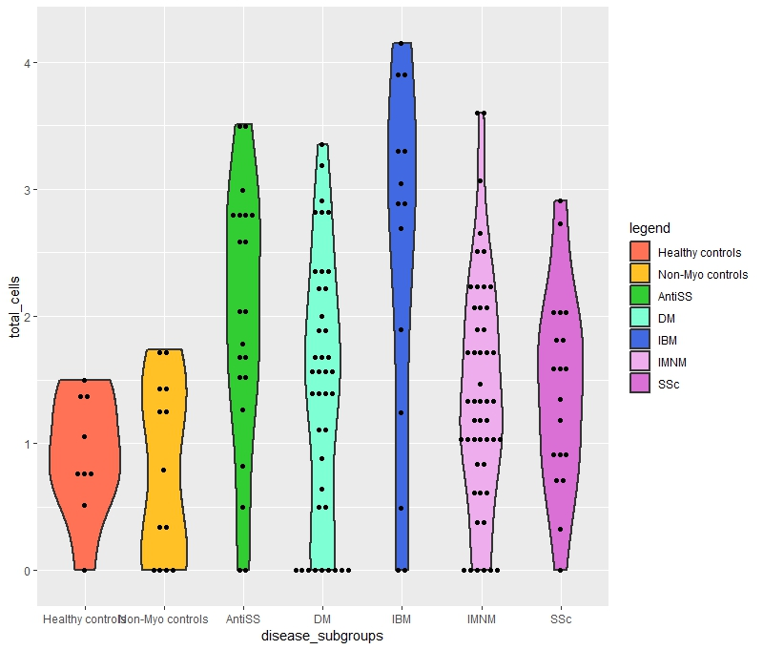
In agreement with previous reports of immunohistochemical analyses, samples from patients with IBM had more T cell clones than any other myositis group. It was found that wells containing IBM biopsies contained a far greater T cell infiltrate, both in terms of cell number and clonal diversity. This is shown in the following violin plot, with the IBM cohort having a wider violin, representing more T cell clones. The values plotted along the y-axis are the log base 10 values of the cell counts.
These polyclonally infiltrated IBM samples are mostly comprised of hyperexpanded clones. Furthermore, using GLIPH, we found that TCR sequences from muscle-infiltrating T lymphocytes contain disease-specific motifs and form disease-specific clusters.
Additionally, clones within these clusters are often more expanded than corresponding unclustered clones, as demonstrated by an anti-synthetase syndrome (Anti-SS) specific cluster (p=0.0001). Sequences in this cluster represented 6/19 (31.6%) Anti-SS patients in the cohort, and suggest a shared antigenic target for these clones in these patients.
Our sequencing method generated quantitative repertoire data sets, producing results very similar to those of Adaptive Biotechnologies, at about a 100-fold reduced cost.

CONCLUSIONS: These findings demonstrate that there are disease-specific T cell clones across patients with inflammatory myopathies that likely target the same antigen. These results also suggest that the analytic approach is economical. This type of analysis can be applied to many diseases, autoimmune and otherwise, to discover disease-relevant T cells and inform further mechanistic studies.

CONTENT CATEGORY: Immunology, Pathology

