Diabetic Retinopathy in the Bronx and Myanmar: A Matched Cohort Study
Lin, Kira1; Schlesinger, Max1; Shrivastava, Anurag1; Rubaltelli, David1; Klein, Richard1
1. Montefiore Medical Center, Bronx, NY, 10461, United States.
BACKGROUND: Diabetic eye disease is a leading cause of preventable blindness, both domestically and abroad. Our population in the Bronx, New York is particularly vulnerable to diabetic complications, largely attributable to the high prevalence of poorly controlled disease, despite relatively easy access to primary care. Developing nations such as Myanmar have relatively poor access to primary care, and should have higher rates of related complications. We aim in this study to compare the prevalence and severity of diabetic retinopathy (DR) in the Bronx and Myanmar, with additional analysis of systemic and ocular comorbidities in these populations.
METHODS: We retrospectively compared a database of diabetic patients who underwent telemedicine screening for DR at Montefiore clinics in the Bronx from June 2014­April 2017 (Telemedicine Group) and patients screened for DR in rural Myanmar in 2016 by Montefiore physicians (Myanmar Group). For further analysis, we then compared the Myanmar Group to an age­ and gender­matched sub­group (Bronx sub­group) from within the Telemedicine Group.
RESULTS: There were 97 patients in the Myanmar Group and 3205 in the Telemedicine Group. The Bronx sub­group included 283 patients from the Telemedicine Group. Basic demographic data is in Figure 1. Rates of vision­threatening retinopathy were significantly higher in the Myanmar group compared to the Bronx sub­group (10% vs 2.8% for severe non­proliferative DR, p=0.02; 13.5% vs 0.35% for proliferative DR, p=0.00). In contrast, for less severe retinopathy, Myanmar had significantly lower rates than the Bronx sub­group (13.5% vs 21.9% for mild/moderate non­proliferative DR, p=0.02). There were also differences in medication use: 30% of patients in the Myanmar group used no diabetic medication, compared to 16% in the Bronx sub­group (p=0.01); 51% of Myanmar patients used 1 medication compared to 31% in the Bronx (p=0.00); 1% of Myanmar patients used insulin compared with 33% in the Bronx (p=0.00). Similar proportions used 2 or more medications. Other data regarding comorbidities is in Figure 2.
CONCLUSIONS: In our cohort, patients in Myanmar had a significantly higher prevalence of DR in its vision­ threatening stages, relative to the Bronx. Differences in other systemic and ocular comorbidities were less striking, suggesting that disparities in the treatment of diabetes, most notably with regard to the use of insulin, may be contributory. These data support the concept that implementing robust diabetic screening, education and treatment programs in the developing world may ultimately prove useful in preventing vision threatening retinopathy .
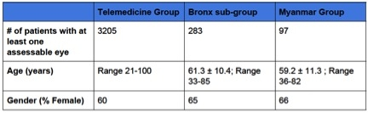  Figure 1: Demographic Data | 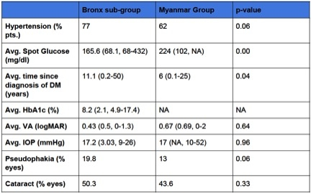  Figure 2: Ocular and Systemic Comorbidities
CONTENT CATEGORY: Epidemiology, Translational Science.
KEYWORDS: Diabetic retinopathy. Bronx USA. Myanmar, Southeast Asia. Screening and preventive medicine. Matched cohort.

