THE ROLE OF CALCITONIN GENE-RELATED PEPTIDE IN DISCOGENIC BACK PAIN

Michael Chang BA, Jose A. Canseco MD PhD, Dessislava Z. Markova PhD, Christopher Kepler MD MBA; Thomas Jefferson University Department of Orthopaedic Surgery and Rothman Orthopaedic Institute; 1015 Walnut Street, Philadelphia, Pennsylvania 19107

BACKGROUND: The prevalence of low back pain secondary to degenerative disc disease cannot be overstated. Recently introduced anti calcitonin gene-related peptide (CGRP) monoclonal antibodies represent an avenue for addressing discogenic back pain by non-operative means.

METHODS: Six (6) unique human intervertebral disc annulus fibrosus (AF) cell lines were used to study the effects of CGRP and proinflammatory mediators of discogenic pain. Cells were seeded on 3D polystyrene scaffolds to mimic the native disc environment. Treatment groups included CGRP 500nM alone, CGRP + erenumab (ligand blockade), CGRP + galcanezumab (receptor blockade), and control. The mRNA was extracted 3-hours post treatment, and reverse transcribed into cDNA. Quantitative RT-PCR was used to determine relative gene expression of the following: TNF-α, IL-6, BDNF (brain-derived neurotrophic factor), and NGF (nerve growth factor). Immunohistochemical staining was used to qualitatively describe the presence of CLR and RAMP1 (surface receptor proteins that bind CGRP) in AF cells. One-way ANOVA was used to assess the effect size across treatment groups with significance set at p≤0.05.

RESULTS: Treatment of AF cells with CGRP led to statistically significant increases in relative fold expression of IL-6 (p<0.0001), TNF-α (p:0.02), BDNF (p<0.01), and NGF (p<0.0001) (Figure 1). Preliminary data samples (n=2) demonstrated approximately 50% reduction in relative fold expression of IL-6 in AF cells pre-treated with either erenumab or galcanezumab before CGRP. There was a similar trend observed for other inflammatory mediators. Figure 2 describes the positive presence of CLR (green)/RAMP1 (red) receptor proteins at the surface of AF cells.

CONCLUSIONS: CGRP blockade at the level of the intervertebral disc represents a potential therapeutic pathway to minimize discogenic back pain and related inflammation.

CONTENT CATEGORY: basic and translational science
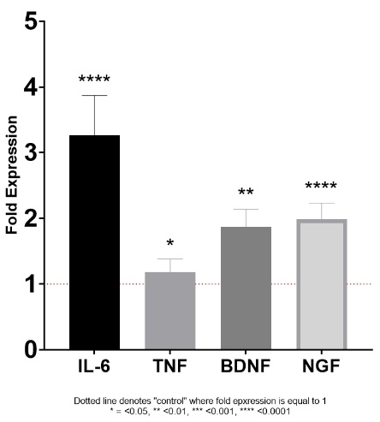
KEYWORDS: low back pain, spine, orthopaedics, CGRP, monoclonal antibodies

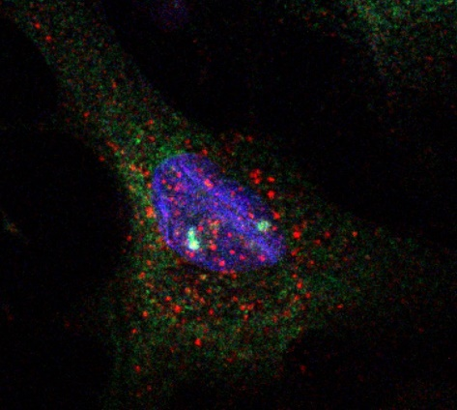
Figure 1. Neurogenic Inflammation after CGRP treatment Figure 2. Immunohistochemical staining for CLR/RAMP1 in AF Cells

