DESIGNING A TELETHERAPY PLATFORM TO CONNECT ELDERLY WITH FAMILY CAREGIVERS

William Ge^{1,2}

¹Harvard Medical School, Boston, MA 02115
²Harvard-MIT Health Sciences and Technology Program, Cambridge, MA 02139

BACKGROUND: One of the most profound challenges that people face in old age is social isolation. Nearly half of elderly currently live alone or with just a spouse, and elderly who live alone are at increased risk for a number of serious behavioral and health problems including cognitive decline, depressive symptoms, reduced physical activity, and increased chronic disease morbidity. Family members often play an inimitably important role in supporting their elderly, especially in filial-tending East Asian households, but their ability to do so is frequently limited by time and distance. This ability has been constrained further by the current pandemic, particularly for cross-continental families with elderly living abroad and families with elderly in nursing homes that have been under perpetual lockdown.

METHODS: To connect isolated elderly to the families who care for them, I designed a new social technology platform to enable family caregivers to provide companionship for their elderly through reminiscence-based teletherapy. The platform was designed in Adobe Xd and Figma and is being prototyped in React.

RESULTS: The platform is based on an app and website which presents shared family photos, audio recordings from family members, and music in multimedia units to evoke precious memories and experiences that the elderly and larger family share. Gem’s design draws from the well-established practice of reminiscence therapy, in which photos, favorite songs, and other treasured objects are used to help individuals recall their personal histories. The beta platform will be made publicly available in early 2021.

CONCLUSIONS: By providing the infrastructure for families to connect with their elderly through meaningful and evidence-based reminiscence, this platform will help connect socially disconnected elderly with their family caregivers around the world.

CONTENT CATEGORY: Patient Care; Translational Science

KEYWORDS: Elderly; Social Isolation; Family Caregiver; Reminiscence Therapy; Gerontechnology

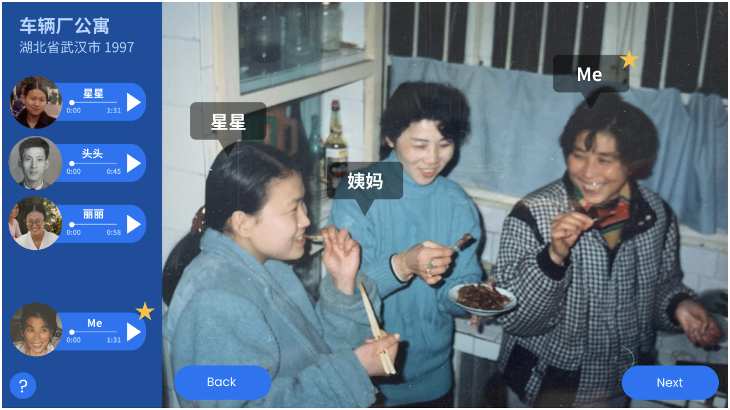
Screen capture from the platform. Pictured, from left to right: my aunt, great-aunt, and grandma celebrating Lunar New Year in an apartment in Hubei, China, in the year 1997. Voice recordings from my grandma and other family members recounting this event are saved on the left.

