QUANTIFICATION OF ULTRA-HIGH RESOLUTION VERSUS CONVENTIONAL RESOLUTION CORONARY COMPUTED TOMOGRAPHY ANGIOGRAPHY: A FEASIBILITY STUDY

Benjamin L. Shou¹, Jason Ortman¹, Mahsima Shabani¹, Joao Lima¹, Armin A. Zadeh¹
¹Division of Cardiology, Johns Hopkins Hospital, Baltimore, MD USA.

BACKGROUND: Conventional resolution (CR) coronary computed tomography angiography (CCTA) is a first-line test for the presence or absence of coronary artery disease (CAD). However, CR-CCTA is limited by its low positive predictive value which may be due to limited spatial resolution. In this feasibility study, we sought to compare vessel features quantified from newly developed ultra-high resolution (UHR) versus conventional resolution CCTA.

METHODS: Patients with suspected or known CAD were enrolled as part of the CORE-PRECISION Pilot Study and underwent UHR-CCTA. Raw image data was back-reconstructed to conventional resolution (CR). A semi-automated, deep learning based histologically validated software was used to characterize and quantify vessel features in the right coronary (RCA), left anterior descending (LAD), and left circumflex (LCX) arteries (Figure 1). Paired Wilcoxon signed-rank test was used to compare differences between UHR and CR features.

RESULTS: Four patients were randomly selected from the CORE-PRECISION cohort (median age = 65, 100% male) for a total of 12 analyzed coronary vessels. Median non-calcified plaque (NCP, 174.1 vs. 408.1 mm³, p < 0.001), calcified plaque (CP, 43.4 vs. 78.5 mm³, p=0.001), and low density non-calcified plaque (LD-NCP, 2.6 vs. 19.5 mm³, p=0.01) volumes quantified from UHR scans were significantly lower than those quantified from CR (Figure 2). Further, median plaque burden (38% vs. 43%, p=0.001) and perivascular adipose tissue volume (PVAT, 226.8 vs. 368.7 mm³, p<0.001) were significantly lower in UHR scans compared to CR.

CONCLUSIONS: Vessel features quantified from ultra-high-resolution CCTA are significantly different than those quantified from conventional resolution. Features from UHR-CCTA may have improved prognostic value over CR-CCTA in the evaluation of coronary artery disease.

CONTENT CATEGORY: Translational Science

KEYWORDS: coronary artery disease, coronary computed tomography angiography

Figure 1. Example of software quantified vessel features on a curved planar reformation view of the left anterior descending artery. CR: conventional resolution; UHR: ultra-high resolution. CALC: calcified plaque; LRNC: lipid-rich necrotic core; IPH: intra-plaque hemorrhage; MATX: non-calcified plaque; PVAT: perivascular adipose tissue. Low density non-calcified plaque equaled LRNC + IPH.

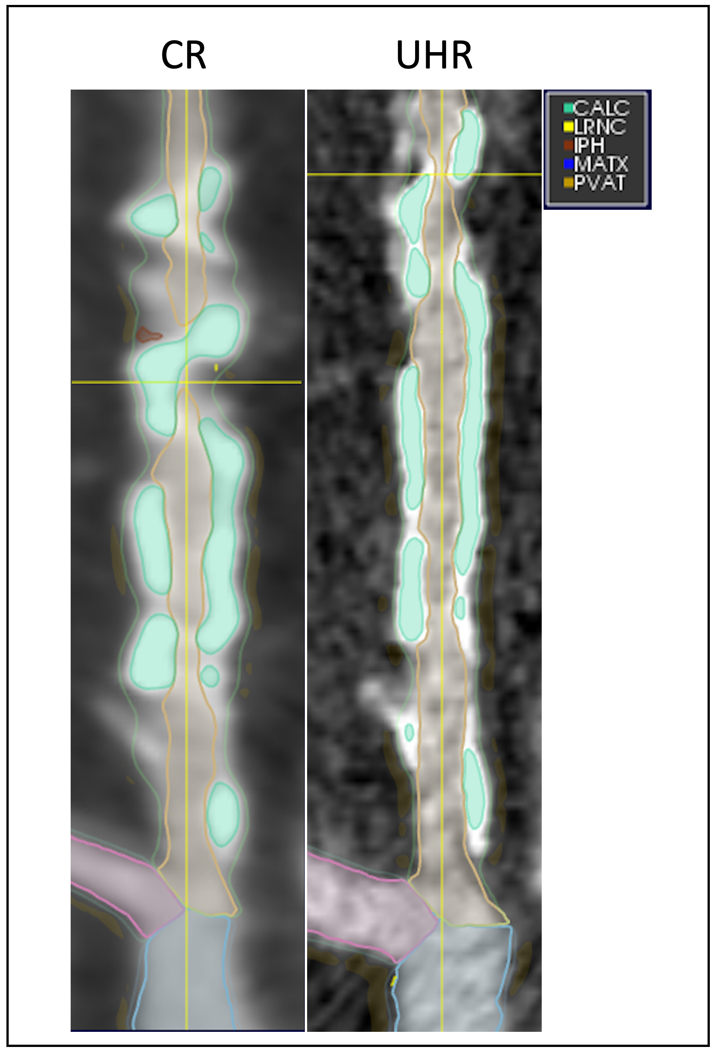

Figure 2. Non-calcified, calcified, and low density non-calcified plaque volume differences between ultra-high and conventional resolution. P values from Wilcoxon signed-rank test for paired values.

